Chapter V: School Wide Action Plan
Action Plan
Goal 1: Provide the appropriate support to all students to increase their individual success.
Rationale:
- Analysis of student data shows that our students are not performing as well as the general school population.

Growth Targets:
- Decrease annually by 5% the number of low performing students with Ds and Fs in their courses
- Increase GPAs by 5 % annually on the low performing students with Ds and Fs
- Increase graduation rate
- Provide more honors courses/AP course to high performing students

ESLRs:
- Lifelong Learner
- Co-operative. Collaborative Learner and Worker
- Complex Thinker and Communicator
- Quality Producer and Productive Member of Society

Resources:
- District funds
- Staff Articulation time
- Aeries
- Academic Supports Classes
- After-School Tutoring
- Benchmark Assessments
- CAASPP
- Parent
- LCAP
Action Steps | Related Tasks | Person(s) Responsible | Student Outcome | Timeline | Assessment/Reporting Methods
Provide staff development to teachers to improve effective classroom instruction. | Identify Essential Elements of Instruction  *Formulate Objective  *Active Participation  *Closure  *Motivation  Provide materials and training for differentiating instruction and scaffolding | Administrative Team  All Teachers | 5% increase of students moving proficiency levels on CAASPP & improve GPA | August 2016-May 2023  May 2017-May 2018 | Faculty Meeting Agendas/Minutes  CAASPP/CELDT Scores  Walk Through Data  Lesson Plans  White Boards  Lesson Objects
Teacher teams will meet to examine student data and make adjustments to the curriculum based on the data, particularly in regards to low performing students and students with special needs. | Identify students early in school year to determine students levels and needs  Identify student levels  Benchmark Assessments Test  Progress Report Cards | All Teachers  Counselor  Administrative Team | Students with Special Needs meet a greater number of IEP goals.  Decrease percent of students with (F) grades on Report Cards by 5% | August 2017  2017-Each Semester thereafter through May 2023 | Agenda/minutes  CAASPP data  School wide Benchmarks  Report Cards

Teachers will utilize common instructional strategies in all classrooms to enable students to connect existing knowledge, construct meaning, modify their own learning and be successful in a challenging, standard based curriculum. These instructional strategies will include literacy and test taking strategies. | Completion of weekly lesson guides.  Uses of literacy strategies.  Essential Elements of Instruction  Staff collaboration on common instructional strategies | Principal  Leadership Team  All Teachers | Increase students’ participation in class.  Increase Student Attendance Rates by 4% | Weekly-Curriculum Calendars  Quarterly Benchmark Assessments  August 2017-May 2023  August 2017-May 2018 | Curriculum lesson guides  Walk-Throughs Data. Teacher peer observations-notes/write ups.  Articulation teacher sharing, agenda/minutes.  Benchmark Assessment Data
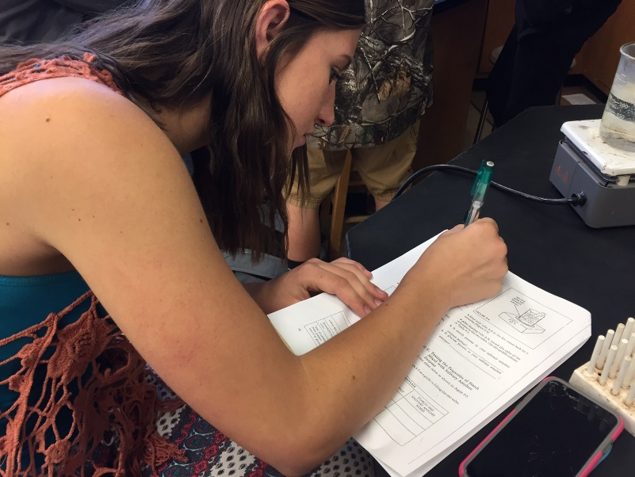
Tutorial support by various content area teachers will continue to be provided for any student not meeting expectations. This support may be in the form of teacher tutorials, peer tutorials, or other opportunities. | Benchmark test  Six week grade checks  Tutoring | All teachers  Tutorial recommendation of students | Decrease of students failing by 5%.  Raise quarterly grades  Raise benchmark test scores | August 2016-May 2017 | SARC report  Benchmark Test  Report card grades with fewer D and F. Student attendance in tutorials.  ESLRs Mastery  Aeries Parent Portal
A variety of instructional strategies, including integration of technology, will be utilized by all teachers to actively engage all learners in the learning process. | Lesson Design  Identify instructional strategies  Identify technology standards | All Teachers | 10% increase in passing benchmarks test  10% Decrease in student referrals  Incorporation of technology in assignments/  project | August 2017-May 2023 | Lesson Guides  Pacing Guides alignment  Data  Walk-Throughs Data  Student Presentation  Student Work

Goal 2: Implementation of California State Standards:

Rationale: The California State Standards will transform the way teachers approach curriculum and will be tracked through quarterly benchmarks.

Growth Targets:
- 100% of all staff will develop awareness of California State Standards
- 100% of all staff will establish California State Standards benchmark test
- 100% of all staff will follow the district quarterly benchmark exams and administering and data reporting

ESLRs Addressed:
- Lifelong Learner
- Co-operative. Collaborative Learner and Worker
- Complex Thinker and Communicator
- Quality Producer and Productive Member of Society

Resources:
- District General Funds
- Staff Development
- Illuminate
- Pacing Guides
- Benchmark Assessments
- Collaboration Time
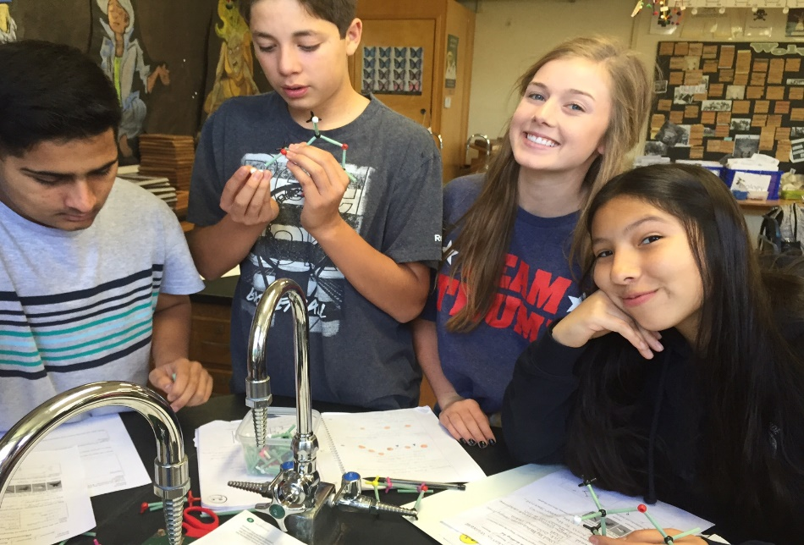

Action Steps | Related Tasks | Person(s) Responsible | Student Outcome | Timeline | Assessment/Reporting Methods
Develop California State Standards awareness in administration, faculty and staff through professional development opportunities | Workshop provided by Butte County Office  Education/Outside Areas | District  All Teachers | Increase knowledge of California State Standards | Yearly-August 2017-May 2023 | Staff knowledge of  California State Standards
Print resources from CDE Brokers of Expertise, and Smarter Balanced Assessment Consortium | Indentify common strategies  Placed in pacing guides | District  All Teachers |  | August 2017-May 2018 | Observations  Staff Development  Agendas/Minutes
Subject level pacing guides and alignment to standards in all subjects. | Updating pacing guides  Creating pacing guides-All subjects | All Teachers | Improve General Grades, Benchmark Assessments | May 2017-May 2023  Required yearly-Updated every 2-weeks | Completed pacing guides. Report card grades Agendas/Minutes  Pacing Charts  Planbook.com
Implement instructional strategies and adapt current curricular resources to facilitate implementation in ELA and Math | BCOE, CDE, BUSD | All Teachers  Middle School Teachers |  | August 2016-May 2023 | Department notes  Professional Development, validation of effective staff use
Classroom Observation and evaluations observing implementations of strategies and standards. | Observation and evaluations | All Teachers  Principal | Improve knowledge | August 2016-May 2023  Required per contract | Articulation Agendas
Goal 3: Use data effectively so that all students will reach their highest academic potential through instruction in rigorous standards- based curriculum.

Rationale: While data is beginning to be used by staff, there needs to be improvement in the analysis and use of the results in order to enhance student performance.
Growth Targets:
- Increase the level of student scoring proficient on district bench mark assessments

ESLRs Addressed:
- Lifelong Learner
- Co-operative. Collaborative Learner and Worker
- Complex Thinker and Communicator
- Quality Producer and Productive Member of Society

Resources:
- District General Funds
- Staff Development
- Benchmark Assessments
- Collaboration Time

Action Steps | Related Task | Person(s) Responsible | Student Outcome | Timeline | Assessment/Reporting  Methods
All departments create and administer benchmark assessments throughout the year, analyzing the data gathered from those assessments, and adjusting instruction based on the data. | Benchmark Assessments in all subjects | All Teachers  Administration | Improved Test Scores  Higher Passing Rate in all classes | Quarterly: August 2017- May 2023  Revise assessment period if needed | Generate Reports  Department minutes  Pacing guides
Professional Learning Communities (team, course-alike, department) meet to analyze and evaluate student learning and make adjustments based on data. | Benchmark Assessments in all subjects | All Teachers  Administration | Improved Test Scores  Higher Passing Rates | End of every grading period (6 weeks)  August 2017-May 2023 | Generate Reports  Department minutes  Pacing guides
All staff will be expected to use a common protocol format to examine student data. | Determine common protocol document | Administration Department Heads | Student understanding of data | August 2015-May 2023  Once established by May 2018 will continue to 2023 | Articulation Minutes  Leadership Team Minutes  Department Minutes  Protocol document
Through Team meeting, staff members will meet and discuss student data and make decisions based on the data examined. | Determine types of data | Leadership Team  All Teachers | Improved grades and test scores | Meet every quarter to determine type of data for that quarter  August 2017-August 2023 | Articulation Minutes  Leadership Team Minutes. List of data to be considered
There will be a school-wide staff development in the use of the data system to support effective student instruction. | Staff | Principal | Improved grades and test scores | August Buy Back (Staff Dev. Days prior to school starting)2017-May 2023 | Buy back sign-in  Teacher knowledge of new data system  In-services agenda and assessment of each. Individual staff demonstration of use of DATA
Implement a multiyear written professional development plan that is founded in BHS critical areas of need. | Indentify priority areas of development.  Indentify past areas of development | Principal  Leadership  Team | Meet identified testing targets | May 2017 Indentify areas of past development  August 2017 Identify priority areas for the year.  Ongoing until May 2023 | Written professional development plan
Develop methods of sharing data with all stakeholders | Data Walls, newsletter, web-pages. | Leadership Team  Teachers | Increase in benchmark scores Increase in student GPA | Monthly Parent Meetings  Last Thursday of every month August 2017-May 2023  Monthly Board Meetings August 2015-May 2023 | Department minutes  Faculty agenda/minutes  SARC Report  Data covering communication process  Board Reports/Minutes
Biggs will continue to provide early release Wednesday to allow time for effective data analysis. | Articulation Calendar | Administration  All Teachers | Student achievement (grades, benchmark test, attendance) | 14 Articulation Days throughout the year  August 2015-May 2023 | Articulation Calendar  Staff evaluation of effective use of data processes and successful applications Agenda for Wednesday meetings

Goal 4: Increase the number of students performing proficient and advanced on Benchmark test, and CAASPP.
Rationale:
- Analysis of student data shows that Biggs High School Students are performing below the state average in Math.

Growth Targets:
- Increase annually by 3% the number of students who improve their benchmark scores in Intergraded Math I.
- Increase annually by 3% the number of students who improve their benchmark scores in Intergraded Math II.
- Increase annually by 3% the number of students who improve their benchmark scores in Intergraded Math III.
- Increase annually by 3% the number of students who complete a third year of math in a core math class.

ESLRs Addressed:
- Lifelong Learner
- Co-operative. Collaborative Learner and Worker
- Complex Thinker and Communicator
- Quality Producer and Productive Member of Society

Resources
- District funds
- Staff Articulation time
- Illuminate
- Pacing guides
- Benchmark Assessments
- LCAP

Action Steps | Related Task | Person(s) Responsible | Student Outcome | Timeline | Assessment/Reporting  Methods
Work with feeder school to access students to insure proper placement of students in math classes | Administer the Placement Test to all 8th grade students.  Teacher recommendation  Current Grade | Math teachers  Administration | Proper placement | Quarterly  August 2017-2023 | Percent of students passing class
Develop Benchmark Assessments for Intergraded I through Calculus, using similar questions as will be used on the state assessment. | Intergraded 1 Benchmark Test  Intergraded 2 Benchmark Test  Intergraded 3 Benchmark Test | Level Teacher | Increase in students scoring proficient on Benchmark tests | May 2017-August 2023 | Binder containing Benchmark Assessments
Give Benchmark Test every 4-6 weeks, using data from test for focus re-teaching and review | Share data in quarterly department meeting | Teachers  Administration | Increase percent of students passing class | Every 4-6 weeks throughout school year | Minutes from department meetings. Data on student scores
Review of pacing guides to ensure the Common Core blueprints are identified throughout the year | Identify the essential standards in each level of math. | Math teachers | Increase percent of students passing class  Improved Benchmark scores | September 2017- May 2023  Review each year in August through 2023 | Verification data of uniform teacher alignment with pacing guides
Use pacing guides to ensure all like courses are progressing at the same rate through material | Ensure all alike teacher have the same pacing guides | Principal | Increase percent of students passing class | August 2017-May 2023 | Pacing guide binder

Goal 6: Develop and implement a multiyear written professional development plan that focuses on the critical areas of need
Rationale:
- A professional development plan is needed to address critical areas of needs that are tied to the standards, ESLRs and school wide vision/mission. Student learning needs to drive the identification of priority areas for professional development.

Growth Targets:
- 70% of students score proficient on benchmark testing provided by the district monitored quarterly

ESLRs Addressed:
- Mature Communicator
- Information Manager
- Problem Solver
- Productive Member of Society
- Life Long Learner

Resources:
- District funds
- Staff Articulation time
- Data Graphs
- Pacing guides
- Benchmark Assessments
- Staff Surveys

Action Steps | Related Task | Person(s) Responsible | Student Outcome | Timeline | Assessment/Reporting  Methods
Staff and administration will develop a list of past professional development strategies that have been studied. | Development of list, reviewed with staff.  Identify levels of teacher expertise and identify ways to support teachers | Teacher  Administration | Increase of students scoring proficient on Benchmark test | May 2017-May 2023  Continue adding to list the spring of each year | Completed list of professional development.  List of teachers needing support
Staff will complete a survey identifying staff development they feel is needed based on student data | Development of and administration of staff survey  Student data | Leadership Team | Increase in the rigor of instruction being received | May 2017-May 2023  Spring and Fall of each school year | Leadership team completing list of identified staff needs.  Prioritizing of list of needs.  Listing of any alignment of staff needs with identified student educational needs
Teachers will meet during articulation to discuss and identify priories for professional development | Scheduled articulation meeting | Principal | Increase in the rigor of instruction being received | August 2017- May 2023  Ongoing Each Year | Minutes from meeting  Professional development list  Calendar of Development
Make sure parent e-mails are updated in Aeries  Biggs High will need to develop a method to evaluating Professional Development to determine its effectiveness | Provide training for teachers  Create Check Off Form  Create List of Professional Development | Principal  Leadership Team  Principal | Parent commutation  Increase of students scoring proficient Benchmark test | May 2017-May 2023 | Parent survey  Leadership Team minutes/agenda’s  Walk Through notes  Observation
Develop expectation of staff for the full implementation of the professional development strategies | Commitment of implementation of professional development | Principal  Leadership Team  All teachers | Increase of students scoring proficient on Benchmark test | August 2017-May 2023 | Binder with signed contract  Revisit during staff Development Days
Develop a plan that shows how the Professional Develop will be reviewed to determine its appropriateness, effectiveness, and need for revision | Develop a survey for teachers and students. | Principal  Leadership Team | Increase of students scoring proficient | May 2017-May 2023 | Benchmark test. Written plans that directs Professional Development review and realignment annually.  Walk through notes.  Observations. Benchmark Data,  Documentation of what’s working with Data.  Yearly documentation reviewing the Professional Development Plan indicating successes

